Oral exam practice

This worksheet and the article are written in American English.

Assignments

Task 1 – Comprehension
Explain the advantages and disadvantages that a four-day workweek (with reduced hours) would entail, as stated by Karla L. Miller in the comment.

Task 2 – Analysis
You might have come across narrative techniques in literary texts, for example, novels and short stories. However, they can also be found in non-literary texts like newspaper articles.
Take a closer look at the introduction (para. 1), the main part (paras. 2–12), and the conclusion (para. 13). Analyze these parts separately and briefly compare the narrative situations used in each of these three parts of the article.

Tip for teachers! A short definition of the narrative situations that apply here can be found in the answer key. For students of lower levels, these can be added here.

Task 3 – Evaluation
Imagine that you are an employer owning your own company. The nature of your business allows a workweek for employees with either five or four days. Would you allow your employees to work their 40 hours per week either during the normal eight hours per day (five-day week) or condensed into four days with ten-hour shifts per day? What would you decide to do and why?

Answer key

Assignments

Task 1: Sample points

Advantages of a four-day workweek (with reduced hours):
• Productivity: Working fewer hours per week does not necessarily mean that you are less productive. You often need as much time to complete a task as you have available; therefore, if you have fewer hours to finish a task, you can probably do it in this reduced amount of time. Working many hours also means getting tired, and the output of workers is reduced over time. (paras. 4, 5).
• Concentration: Because certain tasks require a lot of concentration, they will not necessarily get better the longer you work on them. Six-hour work shifts may actually be much more productive than the common eight hours (para. 6).
• Health: Long-term health problems like high blood pressure are often the result of too much work and stress over a period of time (para. 5), so guarding against these health issues by working fewer hours per week will have many advantages in the long run.
• Working parents: Reduced working hours would be more family-friendly and would mean that parents could coordinate their schedules much better with their children’s and would have more quality-time with the family (para. 7).
• Life-work-balance: The new work model – four days’ work and three days off – seems much more balanced than the traditional five-days-work-and-two-days-off-model (para. 7).

Disadvantages of a four-day workweek (with reduced hours):
• Feasibility: There are jobs where it is simply not possible to cut down on the working hours without harming the business or reducing vital services, for example, emergency services. This includes jobs that are not task-based, for example, those that deal with “client schedules, timed processes, or billable hours”; in these cases, reduced hours would also mean less money for the company and for the employees (para. 8).
• Fairness: Introducing shorter workweeks could be regarded as unfair. Like the 40-hour workweek, a shorter one would not be “consistently and equitably applied,” (see previous point) and those people who would actually deserve a shorter workweek would probably not be able to benefit from it anyway (para. 12).
• Team spirit: Shorter workweeks could have a negative effect on morale and teamwork in the workplace. Colleagues would see each other less and have a different work rhythm. Furthermore, there could be resentment when people rush home after their reduced workhours and no one else is at work to share the workload with when needed. Shared workloads, helping a colleague, or just having a break-time talk increases the sense of camaraderie (para. 9).
• Health: Tasks would need to be reduced (para. 11). Otherwise the workload of 40 hours would be compressed into too little time which would cause stress and not have the expected health advantages. Having more stress albeit in fewer days does not sound like a healthy alternative to the regular working model.
• Lack of resources: For workplaces that are already overloaded and lack employees, the four-day workweek would be a huge problem because they would need either to hire more staff or to reduce their projects and tasks so that they are still manageable with the resources available (para. 11).

Task 2: Sample points

Tip! Definitions of narrative situations that apply to the text.
• First-person narrative situation: The narrator actively participates in the story he or she tells in the text.
• Authorial narrative situation: The narrator knows everything about the story and its characters but does not have an active role in the text. Instead, the narrator tells the story from an outside, omniscient perspective.

Note: Alternative student answers that see the whole text as a first-person narrative may also be correct because first-person narrators can also tell some passages in a less subjective way and provide objective background information too. However, students that adopt this view still need to point out the significant differences between the three parts in their analysis and give reasons for their assessment.

Introduction (para. 1): First-person narrative situation (“I”)
• The very first word of the article is “I,” which provides a personal introduction into the topic (“I don’t know about you …”).
• The narrator addresses the reader directly (“you”), creating a connection and conversation-like situation.
• The author creates a familiar and intimate tone by wondering whether or not the reader has the same issues with too little leisure time over the weekend. This direct involvement adds to the bonding between the narrator and the reader.
• The issues presented are likely to be shared by the reader which establishes common ground. This, together with the personalized, subjective narrative perspective, prepares the reader to be more open to the opinion of the author whose goal it is to convince the readers.

Main part (paras. 2–12): Authorial narrative situation
• In contrast to the first paragraph, the main part is no longer written from the subjective perspective of a first-person narrator.
• Instead, it is an authorial narrative situation, which is an omniscient and much more neutral narrator. The narrator is no longer part of the events but presents information from an all-knowing perspective to inform readers and substantiate arguments with evidence.
• The narrative situation in the main part is much more objective than in the introduction. The author states basic facts and background information that show the advantages and disadvantages of a four-day workweek. Occasionally, an opinion or assessment of the situation shines through which is typical of such narrators (“… counterintuitive as that may seem”, para. 4; “… of course, shorter workweeks have their downside …”, para. 8)
Conclusion (para. 13): Mixture of first-person and authorial narrative situation
• Paragraph 13 seems to be a hybrid because it has aspects of both the first-person and the authorial narrative situation.
• On the one hand, the topic is summarized in a neutral way and more general information is added (“… after decades of increased automation and innovations …”), which is more indicative of an authorial narrative situation.
• On the other hand, the narrative situation returns to the more subjective and personal “we,” which includes both the narrator and the reader. The author appeals directly to the reader to get involved in the issue (“We need to rethink …”) and help bring an end to the five-day week.
• The article ends with a rhetoric question that pinpoints the issue to convince everyone of the need for change: Why is the focus is still on squeezing more work into fewer hours although we know about the downsides this entails?

Task 3: Sample points

Individual student answers. Possible points to include:

PRO: A five-day workweek, eight hours per day
• Tried and tested working model – eight hours work on five days a week are doable.
• Working ten hours a day (for four days a week) is tiring and concentration decreases the longer you work. This could result in poor quality work
• Compressing 40 hours into four days also leads to increased stress, so it seems better to work the regular days than to cram too much work into four days. Increased stress is also bad may also be bad for people’s health.
• If you are at work five days a week, you have more days on which you see your colleagues. That is better than spending tiring ten-hour shifts with them where you need to get everything done in four days. You have more days and possibly more energy to help colleagues and have a quick chat over a cup of coffee, etc. – all these are things that would improve cooperative work with colleagues.
• Commuters would have even longer days.
• Working parents would barely see their kids on the days they work which would corrode daily family routines and continuity.
• …

PRO: A four-day workweek, ten hours per day
• A longer weekend means more quality time with family and friends and more time to relax and socialize over the weekend.
• Three days are a proper break, which is good for your health.
• It gives you the opportunity to go on small holidays over the long weekend, which would mean you are probably more relaxed during the week, even if you have to work longer on the days you are at work.
• It gives you more time to really focus on a task if you have ten hours instead of eight per day.
• You might become more organized and efficient in order to finish off the relevant tasks before the long weekend.
• Interruptions on a ten-hour day are easier to handle than on an eight-hour day. A chat with a colleague may be more welcome when your work day has more hours. Also, team spirit could be boosted when everyone works together to get everything done in four days and be rewarded with a three-day weekend.
• …
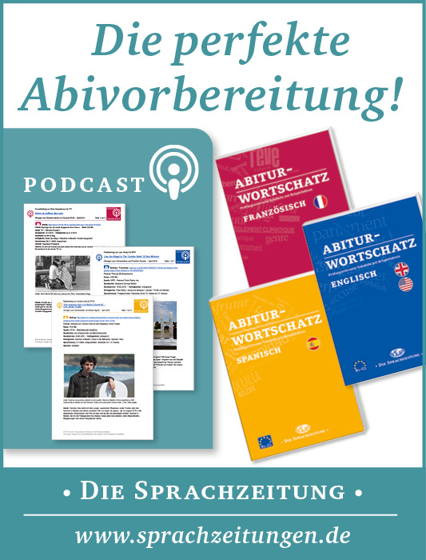

World-and-Press-Sammelbezug für Ihren Kurs oder die Schulbibliothek?
Sie sparen sich lästige Vorbereitungen, und Ihre Schüler/innen stehen nicht mit leeren Händen da, wenn Sie mit dem Übungsmaterial arbeiten wollen!

Hinweis: Mit dem Aktivieren der Links in diesem Dokument gelangen Sie auf fremde Internetseiten.
Wir weisen darauf hin, dass die Carl Ed. Schünemann KG keinerlei Verantwortung für externe Inhalte und deren Darstellung übernimmt. Davon ausgenommen sind Links zu verlagseigenen Webseiten.

Hinweis: Die Zugangsdaten zu Ihrem persönlichen Abo dürfen Sie nicht an Dritte weitergeben.

