Speaking practice

The following exercises will offer you an easy way to use and improve your speaking skills. Answers are given in the answer key.

This worksheet and the article are written in American English.

1. Official desserts in the US

In the US, eight federal states have official desserts. Guess which dessert belongs to which state.

• Massachusetts  • Florida | • South Dakota  • Alabama | • Maine  • Maryland | • Delaware  • Missouri

strawberry shortcake  a) ______________ | Smith Island Cake  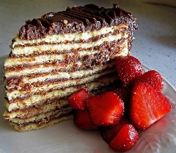  b) ______________ | peach pie  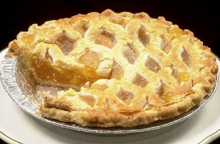  c) ______________ | ice cream cone  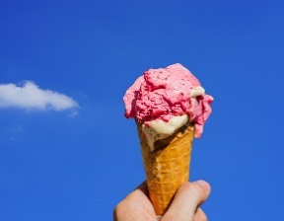  d) ______________
Blueberry pie with wild Maine blueberries  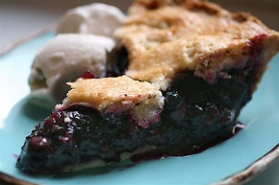  e) ______________ | Kuchen*  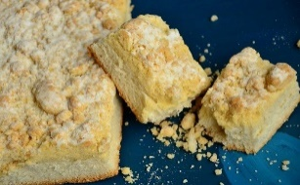  f) ______________ | Boston cream pie  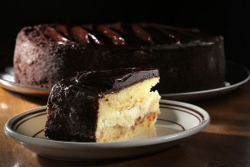  g) ______________ | Lane cake  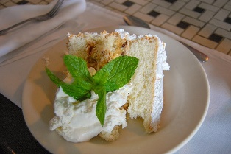  h) ______________

*Kuchen: German-derived term for different types of cakes made of sweet yeast dough

| Photos: For picture sources see answer key

2. Your official dessert

What would you make the official dessert of your town, federal state, and country? Gather ideas with a partner, and share them afterwards. Then take a poll in class.

3. Why have official desserts?

Read through the article again and discuss reasons as to why US states decide to have official desserts by law.

4. Cake idioms

Look at these idioms and guess what they mean.

a) To sell like hot cakes

b) To be a piece of cake

c) The icing on the cake

d) You can’t have your cake and eat it too.

e) Cakewalk

f) Nutty as a fruitcake

g) A slice of the cake

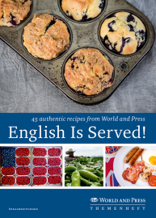

Recipes include:
• pancakes with maple syrup
• banana bread
• full English breakfast
• Shepherd‘s pie
• spicy coleslaw
• butternut squash soup
• Irish stew
• pumpkin gratin
• chicken tikka masala
• Cornish pasties
• Jambalaya
• green bean casserole
• smoothies
… and many more!
Answer key

1.
a) Florida (strawberry shortcake) • b) Maryland (Smith Island Cake) • c) Delaware (peach pie)
d) Missouri (ice cream cone) • e) Maine (blueberry pie with wild Maine blueberries)
f) South Dakota (Kuchen) • g) Massachusetts (Boston cream pie) • h) Alabama (Lane cake)

Picture sources
a) Pixabay
b) Smith Island Cake 2009 by Jane Thomas CC BY 2.0 <commons.wikimedia.org/wiki/File:Smith_island_cake2009.jpg>
c) Getty Images
d) Pixabay
e) Blueberry Pie by thebittenword.com CC BY 2.0 <commons.wikimedia.org/wiki/File:Best_Blueberry_Pie_with_Foolproof_Pie_Dough.jpg>
f) Pixabay
g) Getty Images
h) Slice of Lane cake by Eunice CC BY-SA 2.0 <commons.wikimedia.org/wiki/File:Slice_of_lane_cake.jpg>

2. Individual student answers

3. Possible points: local patriotism, promote one’s culture, support the local economy (in this case agriculture, see paras. 2, 4), promote a dish to tourists and other non-locals

4. Cake idioms

a) To sell like hot cakes: To sell very quickly and easily
b) To be a piece of cake: To be a very easy thing to do
c) The icing on the cake: Something that makes a good thing even better
d) You can’t have your cake and eat it too: You want two things that you can’t have at the same time because they are mutually exclusive. You can only choose one of them (e.g., The UK can’t leave the EU and still want to keep all its benefits.)
e) Cakewalk: Something that is very easy to do
f) Nutty as a fruitcake: Totally crazy, completely mad
g) A slice of the cake: A share of something (usually money) for everyone who contributed to making it

World-and-Press-Sammelbezug für Ihren Kurs oder die Schulbibliothek?
Sie sparen sich lästige Vorbereitungen, und Ihre Schüler/innen stehen nicht mit leeren Händen da, wenn Sie mit dem Übungsmaterial arbeiten wollen!
Hinweis: Mit dem Aktivieren der Links in diesem Dokument gelangen Sie auf fremde Internetseiten.
Wir weisen darauf hin, dass die Carl Ed. Schünemann KG keinerlei Verantwortung für externe Inhalte und deren Darstellung übernimmt. Davon ausgenommen sind Links zu verlagseigenen Webseiten.
Hinweis: Die Zugangsdaten zu Ihrem persönlichen Abo dürfen Sie nicht an Dritte weitergeben.

