Listening comprehension with pre-listening and post-listening exercises

This worksheet and the recording are in American English.

Pre-listening

1. Take a close look at the pictures below.
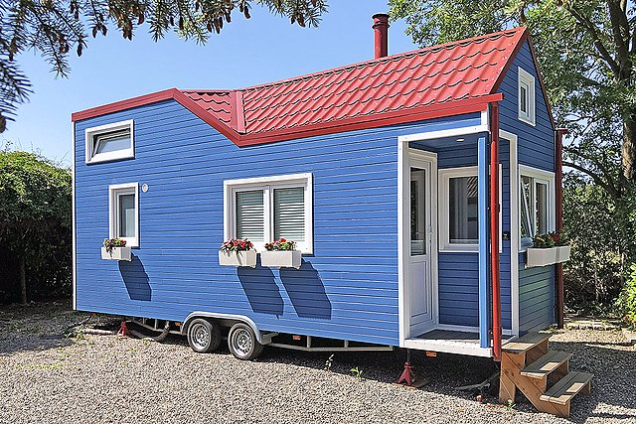  Picture 1 | 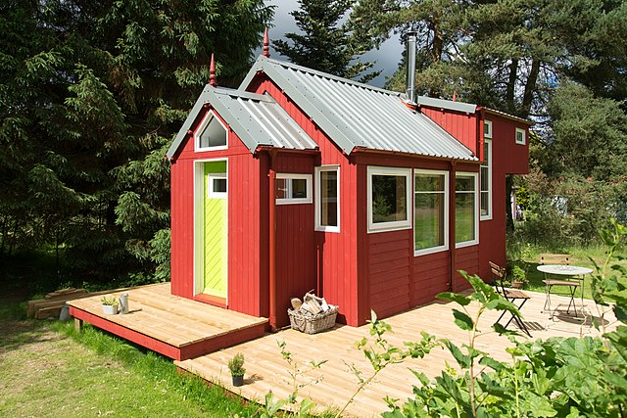  Picture 2
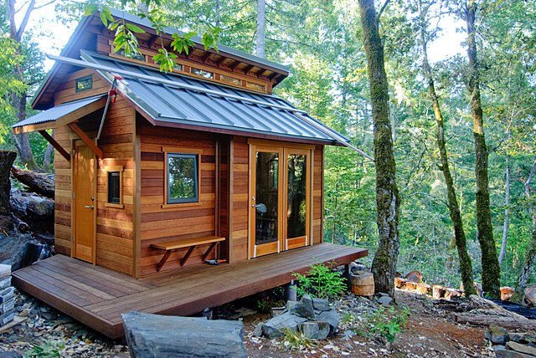  Picture 3 | 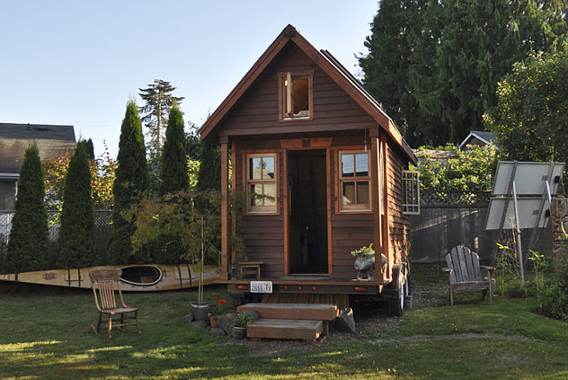  Picture 4
| Photos: For picture sources see answer key

a) Describe what a tiny home is to someone who has never seen one before. What criteria would you use to classify a house as a tiny home? What might you find in a tiny home?
b) Tiny homes are small and have limited space. Write a list of items or features that tiny homes should have. Mark the top five items that your tiny home absolutely must have for you to want to live in it.

2. Vocabulary preparation

In the left column is a list of terms that you will hear in the article. Match each term to its German equivalent in the right column. Write your answers in the spaces provided below.
a) building code | 1 Ableger
b) chronic health condition | 2 Bauordnung
c) encampment | 3 Bebauungsvorschriften
d) godsend | 4 chronische Erkrankung
e) greenery | 5 Drogenmissbrauch
f) housing stock | 6 Einkommensunterschied
g) housing voucher | 7 Geschenk des Himmels
h) ice fishing shanty | 8 Grün
i) income inequality | 9 Mietwohnungen
j) mental health issues | 10 psychische Probleme
k) rentals | 11 Schutzhütte beim Eisangeln
l) spinoff | 12 Siedlung
m) substance misuse | 13 Wohngutschein
n) zoning regulations | 14 Wohnungsbestand

Answers
a) ______ | b) ______ | c) ______ | d) ______ | e) ______ | f) ______ | g) ______
h) ______ | i) ______ | j) ______ | k) ______ | l) ______ | m) ______ | n) ______

Listening comprehension

Before you listen to the recording, read through the questions and tasks below. You will then hear the recording and answer the questions or complete the sentences. Write your answers in the blank spaces or mark (✓) the correct box.

You will have time to listen to the recording again and check your answers.

1. What three things can fit in the tiny homes in Madison, Wisconsin?
• ______________________________
• ______________________________
• ______________________________

2. What do the tiny homes resemble? __________________________________________

3. Where did Gene Cox live before moving into his tiny home?
• _________________________ | • _________________________

4. Occupy Madison is a local _______________ of the national movement that protests against ________________________________.

5. Name a major factor that has pushed the trend to build tiny houses.
_________________________________________________________________________

6. For whom did Arnold Schwarzenegger donate money for tiny houses?
_________________________________________________________________________

7. What does the number seven million refer to?
_________________________________________________________________________

8. Name three health-related issued faced by the homeless according to the 2019 study.
• ______________________________
• ______________________________
• ______________________________

9. Tiny homes vary greatly. What do the larger tiny homes have that smaller ones do not?
• _________________________ | • _________________________

10. Residents of tiny home encampments far from town lack access to these three important things.
• ______________________________
• ______________________________
• ______________________________

11. Mark (✓) the correct box for the following questions. Each question will only have one right answer.

a) How does Donald Whitehead Jr view tiny homes?
☐ better than housing vouchers
☐ a way to permanently fight homelessness
☐ a short-term solution
☐ a means to increase housing availability

b) Which of these has not stopped tiny homes from being built?
☐ zoning regulations
☐ building codes
☐ neighbors
☐ crime prevention programs

c) Which statement about Madison’s newest village is true?
☐ Three types of homes are in one location.
☐ The village is only temporary.
☐ The permanent huts look like covered wagons.
☐ Tiny homes will be added to it.

d) The city’s newest project …
☐ needs to hire a counselor.
☐ looks like fishing shanties.
☐ regularly gives food to its residents.
☐ provides tents to people who can’t get a tiny home.

e) How does Jay Gonstead feel after moving into his new tiny home?
☐ very content
☐ overwhelmed by emotion
☐ jumping for joy
☐ humbled

Post-listening

1. With a partner, brainstorm about the both the positive and negative environmental impact of a tiny home.

2. Design your own tiny home. Think about your list of must-have items in pre-reading exercise 1b.

If you need inspiration, look up other tiny homes on the internet. Your tiny home should be approximately 4 meters tall, 12 meters wide, and 2.5 meters wide. Remember that it needs to be tiny! Apart from including all necessary items and facilities, what material would you choose for your tiny home and how would you decorate it?

3. With a partner, consider what other factors must be taken into account (apart from a functioning home) to make tiny home communities a permanent option to fight against homelessness.

World-and-Press-Sammelbezug für Ihren Kurs oder die Schulbibliothek? Sie sparen sich lästige Vorbereitungen, und Ihre Schüler/innen stehen nicht mit leeren Händen da, wenn Sie mit dem Übungsmaterial arbeiten wollen!

Hinweis: Mit dem Aktivieren der Links in diesem Dokument gelangen Sie auf fremde Internetseiten. Wir weisen darauf hin, dass die Carl Ed. Schünemann KG keinerlei Verantwortung für externe Inhalte und deren Darstellung übernimmt. Davon ausgenommen sind Links zu verlagseigenen Webseiten.

Hinweis: Die Zugangsdaten zu Ihrem persönlichen Abo dürfen Sie nicht an Dritte weitergeben.
Answer key

Pre-listening

1.
a) Individual student answers but main points should include:
• are very small (the entire interior space can be approximately 100 square meters, but usable space will only be approximately 15 to 45 square meters)
• require less land than a full-sized house
• sometimes built on wheels and can be moved (pictures 1, 4)
• often resembles an actual home rather than a camper or travel trailer
• usually has only one room
• often made of wood
• situated out of town, surrounded by nature
• sometimes has a loft for a bed or storage
• could have a ladder or even a small staircase that doubles as storage space
• saves space by having fold-out tables and beds

b) Individual student answers
Sample list:
• bed • electricity • kitchen • bathroom, including shower and toilet • washing machine
• desk • storage for clothing and shoes • bookshelves • terrace or patio • a loft area
• hot and cold water • refrigerator • heating system • television • …

Picture sources
Picture 1: “Tiny House auf PKW-Anhänger” by Küste, CC BY-SA 4.0, <de.wikipedia.org/wiki/
Datei:Rolling_Tiny_House_mit_Pelletofen_auf_PKW-Anh%C3%A4nger.jpg>
Picture 2: “The NestHouse™ tiny house designed and built by Jonathan Avery of Tiny House Scotland, Linlithgow UK” by Cavajunky, CC BY-SA 4.0, <en.wikipedia.org/wiki/File:JA6_4484.jpg>
Picture 3: “Example of a tiny home, built amidst nature“ by Ben Chun, CC BY-SA 2.0, <de.wikipedia.org/wiki/Datei:Cabin-Like_Tiny_Home_in_the_Woods.jpg >. The picture has been cropped to fit the space.
Picture 4: “A tiny, mobile house in a Portland, Oregon yard“ by Tammy, CC BY 2.0, <en.wikipedia.org/wiki/File:Tiny_house_in_yard,_Portland.jpg>

2. a) 2 • b) 4 • c) 12 • d) 7 • e) 8 • f) 14 • g) 13 • h) 11 • i) 6 • j) 10 • k) 9 •
l) 1 • m) 5 • n) 3 •

Listening comprehension

1. cot • refrigerator • personal belongings (subhead)
2. people-sized birdhouses (para. 1)
3. rentals • van (para. 2)
4. spinoff • income inequality (para. 3)
5. rising housing costs (para. 4)
6. homeless veterans (in Los Angeles) (para. 4)
7. affordable homes needed (in the US) (para. 5)
8. Any three of the following: chronic health conditions, trauma, substance misuse, and mental health issues (para. 5)
9. kitchens • bathrooms (para. 6)
10. jobs • grocery stores • social services (para. 7)
11. a) ☑ a short-term solution (para. 8)
b) ☑ crime prevention programs (para. 9)
c) ☑ The village is only temporary. (para. 10)
d) ☑ looks like fishing shanties. (para. 11)
e) ☑ overwhelmed by emotion (para. 12)

Post-listening

1. Sample points

Positive points about environmental impact
Materials
• The most important point is that they require fewer materials to be built and repaired.^{1,2}
◦ Fewer materials means reduced transportation costs and less of an impact on the environment.
◦ Because they require fewer materials, recycled materials can also be used.^{1,3,5}
◦ Because of their small size, tiny homes can make more use of environmentally friendly materials, which tend to be more expensive but sustainable.^{1,2}
◦ The costs for repair are greatly reduced because a tiny home has fewer things that need costly replacements over time. For example, the roof is smaller; there will be only one bathroom.
• Lifestyle
◦ The carbon footprint for tiny homes is smaller because they cost less to heat and have less space for electrical appliances.^{1,2,4}
◦ According to a study, people reduced their carbon footprint by approximately 45% after moving into a tiny home.²
◦ Tiny house dwellers generate less waste because they don’t have the space to buy and store unnecessary items. Less space means less waste in terms of packaging.^{1,2}
◦ Tiny home dwellers also changed their lifestyles, including adopting more sustainable eating habits, recycling more, using more sustainable modes of transportation.²

Negative points about environmental impact
• A vehicle with a lot of horsepower, like a truck, is needed to move a tiny home on wheels, and that will require a lot of fuel.³
• Tiny homes often aren’t in cities, so people need to rely on cars to travel further to work or grocery stores and other infrastructure. Tiny homes in rural areas increase their carbon footprint in terms of transportation costs.³
• Tiny home dwellers eat out more often.³ This behavior may not be environmentally friendly depending on how far they travel to get food and what they are eating.
• Tiny homes don’t use land very efficiently. More people can be housed in an apartment building than if the equivalent land space was used for tiny homes.⁵

Sources
¹ “Can Tiny Houses Help the Environment” by Nicholas Tippins. Love to Know. <greenliving.lovetoknow.com/low-impact-living/can-tiny-houses-help-environment>
² “When people downsize to tiny houses, they adopt more environmentally friendly lifestyles” by Maria Saxton. The Conversation. April 10, 2019. <theconversation.com/when-people-downsize-to-tiny-houses-they-adopt-more-environmentally-friendly-lifestyles-112485>
³ “Why Tiny Homes Are Eco-Friendly — And Why They Sometimes Aren't” by Andrew Krosofsky. Green Matters. November 13, 2020. <www.greenmatters.com/p/why-are-tiny-homes-eco-friendly>
⁴ “Are Tiny Houses Sustainable? Here’s How They Can Save You Money and Energy” by Stephanie Osmanski. Green Matters. January 7, 2021. <www.greenmatters.com/p/how-sustainable-is-a-tiny-house>
⁵ “Asking the Right Questions about Tiny Houses” by Robert Pulster. United States Interagency Council on Homelessness. September 29, 2016. <www.usich.gov/news/asking-the-right-questions-about-tiny-houses/>

2. Individual student answers
The tiny home shouldn’t be so big that it is no longer a tiny home. The students can also use graph paper to help them with the design. Amenities such as toilets have a standard size, which should be realistic on the students’ plans. Students’ decoration should give the home an individual touch.

3. Individual student answers
Sample points
• Safety: The tiny home communities should make residents feel safe.
• Inclusion in community life (on equal terms):
° The tiny home communities should offer a sense of community.
° The neighborhoods also need to be developed in such a way that the residents don’t feel “less deserving” (see para. 8 of the article).
° Residents should be made to feel as an active participant in their community, which could include group activities.
° The tiny home communities should also not separate or ostracize the homeless from the rest of society.
• Health care: The communities need to offer a support system for residents’ physical and mental health.
• Jobs: They should also offer residents opportunities to develop job skills and find employment.
• Personal development: A tiny home community should help its residents to learn to be independent.

For more information, see the website of the US Interagency Council on Homelessness, <www.usich.gov/news/asking-the-right-questions-about-tiny-houses/>.

