Listening Comprehension Test

Both the report and the test are in British English.

You have two minutes to read through the questions. You will then hear the recording. Mark (✓) the correct box. There will be a pause of one minute before you hear the text again. You will then have two minutes to check your answers.

1. Canada’s new programme draws a close connection between health and nature.
☐ true ☐ false

2. The national parks involved have to meet specific criteria.
☐ true ☐ false

3. The programme considers body and mind.
☐ true ☐ false

4. A programme like that was first started in Britain.
☐ true ☐ false

5. Canada’s programme will lead to more investment in conservation of nature.
☐ true ☐ false

6. Critics say the programme benefits people who can afford going to the parks anyway.
☐ true ☐ false

7. Canada’s environment minister supports the programme.
☐ true ☐ false

8. Canada’s doctors have used nature as a therapy for patients before.
☐ true ☐ false

9. The new prescriptions order patients to go to a national park two times a week.
☐ true ☐ false

10. Treatment involving nature is described as looking at human beings as a whole and not just parts of them.
☐ true ☐ false
Answer key

1. ☑ true (headline, subhead)
2. ☑ false (para. 1)
3. ☑ true (para. 1)
4. ☑ false (para. 2)
5. ☑ false (para. 2)
6. ☑ false (para. 3)
7. ☑ true (para. 4)
8. ☑ true (para. 5)
9. ☑ false (para. 5)
10. ☑ true (para. 6)
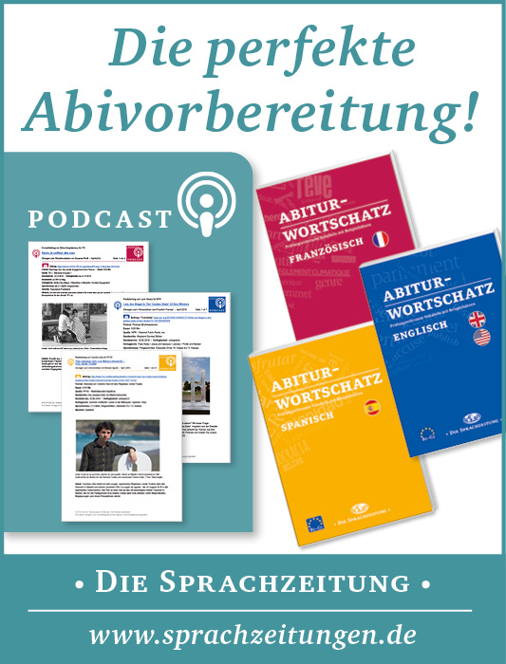

World-and-Press-Sammelbezug für Ihren Kurs oder die Schulbibliothek?
Sie sparen sich lästige Vorbereitungen, und Ihre Schüler/innen stehen nicht mit leeren Händen da, wenn Sie mit dem Übungsmaterial arbeiten wollen!
Hinweis: Die Zugangsdaten zu Ihrem persönlichen Abo dürfen Sie nicht an Dritte weitergeben.

