Speaking practice

The following exercises will offer you an easy way to use and improve your speaking skills.
This worksheet and the article are written in British English.

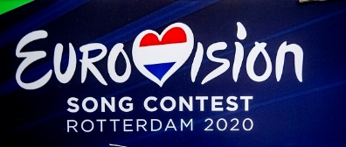
1. The Quiz: Eurovision Song Contest

• Split the class up in two teams.
• Appoint quiz master who reads out the questions.
• For each question, one student from each group
goes to the front of the class.
• Whoever answers the question first, wins the
point for the group.
| Photo: Getty Images
• If none of the students can answer, the question is given to the groups.
• Tip! If a question asks for a number or a certain year, both students can guess. Whoever is closer to the answer wins the point.

The ESC Quiz
Q1 What is the maximum score an ESC participant can get?
Q2 Where does the ESC take place?
Q3 Which legendary Swedish group got famous by winning the ESC?
Q4 Which country won the ESC most often?
Q5 What year did the first ESC take place?
Q6 How many countries took part in the first ESC compared to 2022?
Q7 True or false: After Brexit, the UK can no longer to take part.
Q8 Which English-speaking, non-European country takes part in the contest? (Bonus point: Do you know why?)
Q9 How often did the UK receive zero points?
Q10 How often did Germany receive zero points?
Q11 Who won the ESC more often – the UK or Germany?
Q12 Who organises the ESC?
Q13 Who are the “Big Five”?
Q14 What language are participants allowed to sing in?
Q15 True or false: You cannot vote for your own country.
(Answers are on page 3 of this worksheet.)

2. Further discussion: The power of song?

The American Song Contest takes place for the first time this year. It is inspired by the Eurovision Song Contest like the Bundesvision Song Contest was, which took place in Germany between 2005–2015.

Discuss these quotations taken from our article, and debate whether or not such music competitions help to overcome differences.

Statement 1:
“For more than 50 years, European countries have been able to settle their differences by awarding their enemies “nul points”. Now American states could have the chance to do the same. US citizens will soon have a new outlet through which to air their grievances with each other …” (para. 1)

Statement 2:
“Ben Silverman, executive producer of the American Song Contest, is hopeful that the series will help to heal American divides. He told the ‘NME’: ‘When America is more factionalised than ever and we are dealing with so many issues that divide us, the one [thing] that truly unites us is our culture ... It can unite [us] by celebrating its diversity, its distinctions, and in pulling everyone [together] around its love of music and its love of song.’” (para. 4)

Statement 3:
“America seeks harmony with answer to Eurovision.” (headline)

Tip! Some ideas for answers are given on page 3 of this worksheet.

1. Quiz answers

Q1 12 points (What is the maximum score an ESC participant can get?)
Q2 The location changes every year; the ESC always takes place in the country of last year’s winner (Where does the ESC take place?)
Q3 ABBA (Which legendary Swedish group got famous by winning the ESC?)
Q4 Ireland; 7 titles (Which country won the ESC most often?)
Q5 1956 (What year did the first ESC take place?)
Q6 7 vs. 41 countries (How many countries took part in the first ESC compared to 2022?)
Q7 False! (True or false: After Brexit, the UK can no longer to take part.)
Q8 Australia (Which English-speaking, non-European country takes part in the contest?)
Participants don’t need to be European; Australia has a huge ESC fan base (Bonus point: Do you know why?)
Q9 2 times (How often did the UK receive zero points?)
Q10 3 times (How often did Germany receive zero points?)
Q11 UK: 5 titles; Germany: 2 titles (Who won the ESC more often – the UK or Germany?)
Q12 the European Broadcasting Union, EBU (Who organises the ESC?)
Q13 France, Germany, Italy, Spain, United Kingdom; have a set place in the final; big contributions – financially and in terms of viewership (Who are the “Big Five”?)
Q14 Any language (What language are the participants allowed to sing in?)
Q15 True! (True or false: You cannot vote for your own country.)

2. Possible points

Yes
• It’s a fun outlet to air your grievances and can therefore bring some lightheartedness back into rivalries.
• Music is a uniting force and can be a start in bringing people back together.
• It can be a reminder of a shared culture and identity (American, German, European).
• Sport and music competitions might not solve issues but contribute to a political debate too.

No
• Minor differences and grievances may be settled but some issues are too serious.
• Friendly rivalries can be softened (or playfully strengthened), but it’s naïve to believe this helps with serious issues.
• Music can only do so much but isn’t a tool to solve divisions or even conflicts.
• Because some of the statements are said with a sense of sarcasm (statement 1) or for promotional purposes (statement 2), they should be taken with a grain of salt.

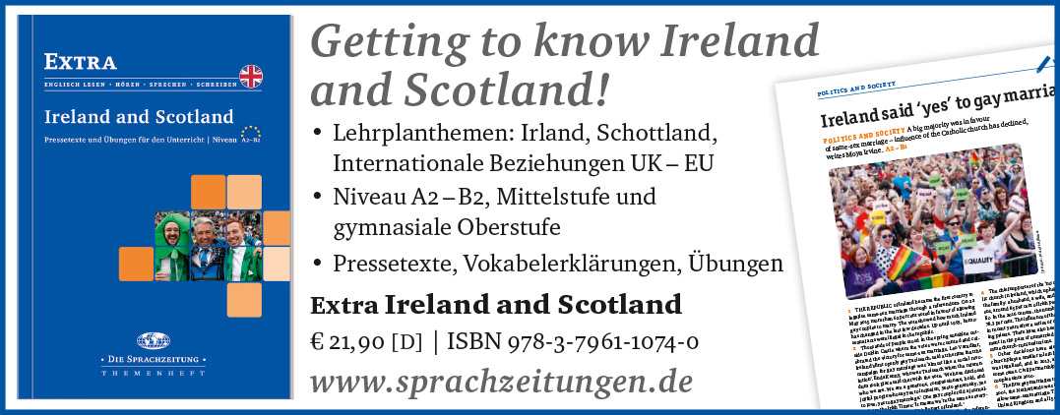

World-and-Press-Sammelbezug für Ihren Kurs oder die Schulbibliothek?
Sie sparen sich lästige Vorbereitungen, und Ihre Schüler/innen stehen nicht mit leeren Händen da, wenn Sie mit dem Übungsmaterial arbeiten wollen!

Hinweis: Die Zugangsdaten zu Ihrem persönlichen Abo dürfen Sie nicht an Dritte weitergeben.

