Useful expressions are words that should be learned together. Memorize them, use them, and your English will sound more natural. The following useful expressions can be found in this issue of Read On.

English | German | Example
to make ends meet (p. 1) | (fig) über die Runden kommen | … millions of Britons are struggling to make ends meet.
there’s no way (p. 2) | (coll) nie im Leben | … there was no way they would survive 56 people awarding their points …
to have a bad rap (p. 3) | (coll) einen schlechten Ruf haben | In popular culture, the “gamer” has had a bad rap for years.
to be up and running (p. 4) | (fig) in Betrieb sein | The site should be up and running in 2027.
to draw s.o. (p. 4) | jdn. anziehen | … and would draw workers from parts of the state with high unemployment.
to blur the lines (p. 5) | die Grenzen verschwimmen lassen | Influencer marketing has blurred the lines between advertising and entertainment.
to mean business (p. 5) | (fig) es ernst meinen | To mean business is to be serious.
to take place (p. 6) | sich ereignen | At the time the act was signed into law, the American Civil War was taking place.
to focus on s.th. (p. 7) | den Schwerpunkt auf etw. legen | The charity Mercy Ships focuses on sub-Saharan Africa …
to turn nasty (p. 8) | unangenehm warden | … about childhood in a beautiful city just as things were turning nasty.

Exercises: Useful expressions

1. Match the useful expression with its meaning.

a) to make ends meet | A to attract s.o.
b) there’s no way | B to happen
c) to draw s.o. | C to be serious
d) to mean business | D s.th. won’t happen
e) to take place | E to make enough money for basic needs

a) ______ | b) ______ | c) ______ | d) ______ | e) ______

2. Match the useful expression with its opposite meaning.

a) to have a bad rap | A to become pleasant
b) to be up and running | B to ignore
c) to blur the lines | C to have a good reputation
d) to focus on | D to make the boundaries clear
e) to turn nasty | E to be shut down

a) ______ | b) ______ | c) ______ | d) ______ | e) ______

ANSWER KEY

1. a) E b) D c) A d) C e) B

2. a) C b) E c) D d) B e) A

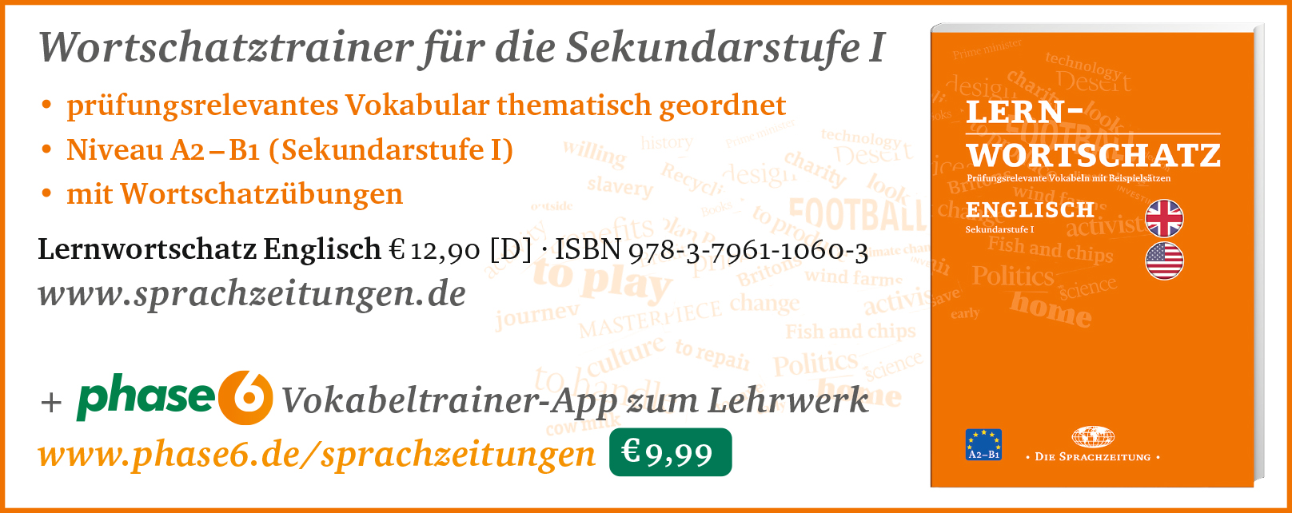

Hinweis: Die Zugangsdaten zu Ihrem persönlichen Abo dürfen Sie nicht an Dritte weitergeben.

