Pre-reading

Take a look at this map of the United States of America. Working in groups, try to find a–d (below) on the map. You’ll need markers or colored pencils in the colors light blue, dark blue, yellow and red.

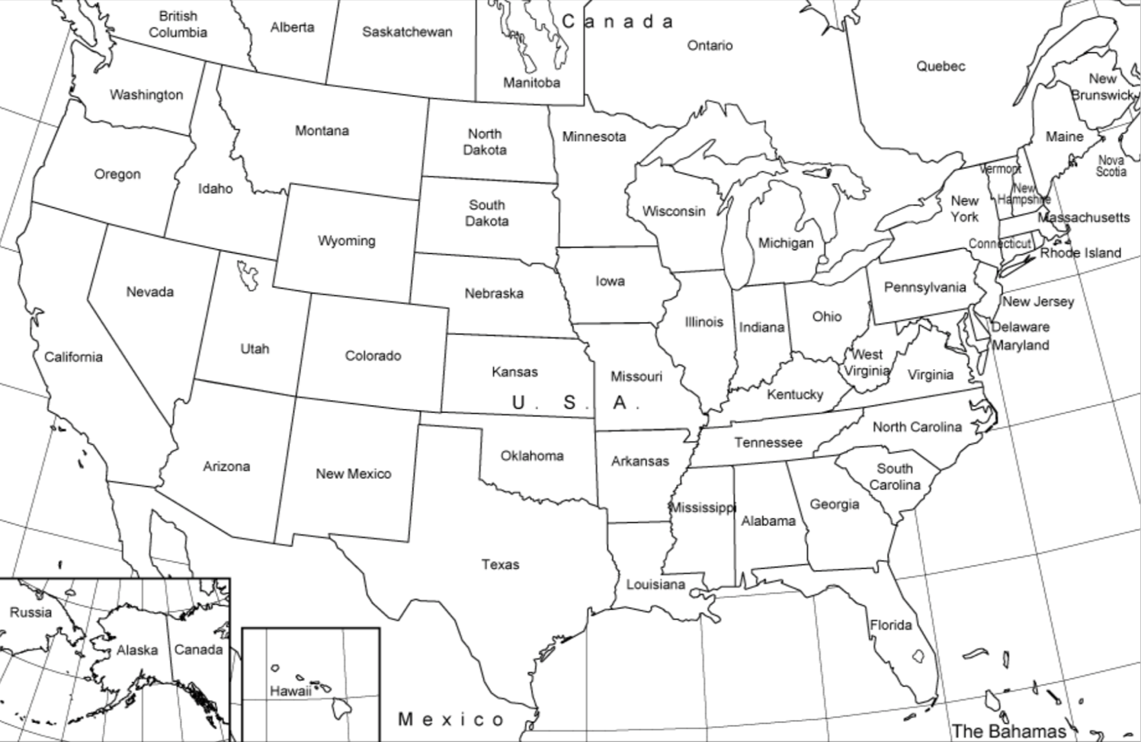

  - Find the Atlantic and the Pacific Ocean. Color these in with light blue.
  - Now find Delaware, Maryland, Kentucky and Missouri. Shade these in with light blue. Color in all the states to the NORTH of these, including West Virginia, in dark blue.
  - Locate Oklahoma, Kansas, Nebraska, South Dakota and North Dakota. Color these in yellow.
  - Now color in everything to the SOUTH of the yellow and blue states in red.

You’ve just created a map of the Northern states (dark blue), the Southern states (red) and the western border (yellow) as it was during the time of the Homestead Act. The light blue states are the border states – the states between the North and the South.

Reading comprehension

- Read the article once, then read the first three paragraphs again more carefully. Build questions with the keywords on the left to match the answers on the right. The paragraph numbers are there to help you.

Who | landowners | Homestead Act: | poor people, former slaves, women, immigrants (para. 3)
What | receive | Homestead Act: | a 160-acre plot of public land for a small filing fee (para. 3)
When | Homestead Act | signed: | May 20, 1862 (para. 1)
Where | people | move | Homestead Act: | the West of the United States (para. 2)
Why | Homestead Act | signed: | to encourage people to move out West  (para. 1)
How | receive | free: | by paying a small fee and living on the land while improving it for five years (para. 3)

- Now read the rest of the article to find answers to the questions below. Write full sentences and use your own words.

a) Who was the Homestead Act closed to?
__________________________________________________________________________
__________________________________________________________________________

b) Which part of the United States did not support slavery?
__________________________________________________________________________
__________________________________________________________________________
c) What were the two groups who opposed the Homestead Act and why?
__________________________________________________________________________
__________________________________________________________________________
d) Why was the Civil War important to the success of the Homestead Act?
__________________________________________________________________________
__________________________________________________________________________

- Decide if the following statements are true (T), false (F), or not mentioned in the article (N).

 | Statement | T | F | N
a) | President Lincoln signed the Homestead Act of 1862. | Ο | Ο | Ο
b) | Most Americans lived in the eastern part of the United States in 1862. | Ο | Ο | Ο
c) | The Homestead Act gave a 60-acre plot of land to citizens for free. | Ο | Ο | Ο
d) | One of the requirements of the Homestead Act was to live on and improve the land for five years. | Ο | Ο | Ο
e) | The western part of the United States was unoccupied in 1862. | Ο | Ο | Ο
f) | The Homestead Act was not open to Native Americans. | Ο | Ο | Ο
g) | The Southern states wanted the Homestead Act to pass. | Ο | Ο | Ο
h) | It was easy for Americans to keep the land the Homestead Act gave them. | Ο | Ο | Ο
i) | The Homestead Act ended because there was no more land to be given away. | Ο | Ο | Ο

Vocabulary
- The following words are used in this article. Working in pairs, take turns to describe one of the words, but don’t tell your partner which word you’ve chosen – your partner has to guess it from your description! Continue until you have described all of the words.

westward government plot public

fee slave Native American immigrant
reservation federal settler majority

- This table contains English expressions that are used in the article. Match them with the correct German translations on the right. The paragraph numbers are given to help you, but first try to find the answers without looking at the text. Write your answers in the boxes below.

Zu dieser Übung bieten wir Ihnen auch eine Online-Übung an. Sie finden sie als H5P-Übung in Ihren Downloadprodukten und können sie dann auf Ihrer Lernplattform einbinden – oder Sie nutzen die Übung direkt auf unserer Webseite. Das Passwort lautet: H5P-RO

English expression | German translation
- to file for something (para. 3)  - to claim something (para. 4)  - to sign an act into law (para. 5)  - to come to be (para. 5)  - to vote against something (para. 6)  - to outlaw something (para. 7)  - to oppose something (para. 7)  - to have something in mind (para. 9)  - to become reality (para. 9) | - etwas im Sinn haben  - entstehen  - etwas ablehnen  - etwas beantragen  - etwas verbieten  - Wirklichkeit werden  - ein Gesetz unterzeichnen  - gegen etwas stimmen  - Anspruch auf etwas erheben

a) | b) | c) | d) | e) | f) | g) | h) | i)

Post-reading

- Imagine you are going to become a settler, claiming a plot of land in the Wild West under the Homestead Act. What risks could there be in homesteading a large piece of land in an unknown territory? How can you best prepare for those risks? What do you think you will need? Discuss in pairs and write down your answers.
- _________________________________________________________________________

- _________________________________________________________________________
- _________________________________________________________________________

- _________________________________________________________________________

- _________________________________________________________________________

- Now it’s time for a role play. The role play takes place at Peck’s General Store – it’s the central meeting spot in town and the place where settlers who want to move westward go to buy the things they need for their move. There are five roles; the Homestead Act has a different effect on each one. The roles are:

  - Role 1: Rob Peck, General Store Owner
  - Role 2: Jacob Downing, Settler
  - Role 3: James McGarvey, Town Mayor
  - Role 4: Eliza Hubbard, Settler
  - Role 5: Sam, Settler

- Now decide who will play each role and then read the description for your role only below. Don’t read the descriptions for the other roles – you want to be surprised during the role play!

- Role 1: You are Rob Peck, owner of the General Store. Start the role play by introducing yourself and your store, greeting your customers and finding out what they need. It’s not all about the money for you, but you do see the chance to make extra money by selling lots of supplies to homesteaders. Be sure to offer everything that your customers may need – and more!
- Role 2: Your name is Jacob Downing and you are on the move with your whole family. You see the Homestead Act as the only way your children can have a future. It's a big risk, however, so you want to be sure that you have enough food, clothing and building supplies for a good start. You are at Peck's General Store and you are open to tips!

- Role 3: You are James McGarvey, town mayor and member of Congress who did not vote for the Homestead Act. You are afraid that too many people will move West and that this will be bad for the economy in your city. You are at the General Store and are doing your best to tell people reasons for staying.
- Role 4: You are Eliza Hubbard – an independent woman who is looking for adventure. Most people think you’re crazy for moving out West on your own. You need supplies for your trip. Write a short list of the most important supplies you need and try to get the best price you can.

- Role 5: You are Sam, a freed slave, and you don't have much money, but this is your chance to build a life of your own and become rich. You think it would be a good idea to join another settler moving westward. Offer help and see if they will bring you along in their team.

- Before beginning, you need to prepare your ideas and goals for your character. Start by reading the article again from the perspective of the role that you have chosen. What information does the article give that is important for your role? Write down these points in Column 1 below, and then think of some words and phrases that you may want to use in the role play as you express your opinion and write them in Column 2.
Role: ________________________
Column 1:  Information on this role from the text | Column 2:  Words, expressions and phrases for your character

- Once your notes are complete, it’s time to start the role play! The owner of the General Store, Rob Peck, will open the role play.
Be sure to:
  - Get in character – speak in the first person
  - Introduce yourself
  - Use every chance to add to the conversation and talk about your viewpoint

- In perhaps a different way than the settlers, we too are confronted with an uncertain future. Wars, inflation, pandemics, potential food shortages and power outages are both present-day and future concerns. What can you do as a “modern-day homesteader” to reduce these risks? Do you think it’s important to prepare for what may come? What are some ways that you can prepare? Write down your ideas below and then discuss your answers in the group.
_________________________________________________________________________
_________________________________________________________________________
_________________________________________________________________________
_________________________________________________________________________
_________________________________________________________________________

Answer key

Pre-reading
Graphic sources: https://mapsofusa.net/free-printable-map-of-the-united-states/
and www.mapchart.net
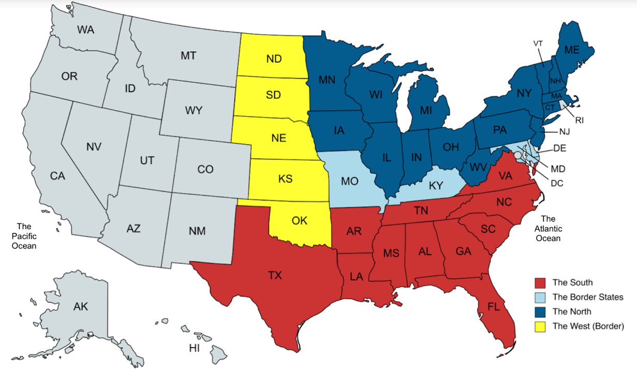

Reading Comprehension
- Student questions will vary slightly, but should be similar to:
Who could become landowners under the Homestead Act?
What did people receive under the Homestead Act?
When was the Homestead Act signed?
Where did people move under the Homestead Act?
Why did the government pass the Homestead Act?
How did people receive the land for free?

- Student answers will vary. Example answers are:

  - The Homestead Act was closed to Native Americans and those who had fought against the federal government in the Civil War.
  - The North (or the Union) did not support slavery.

  - The two groups that opposed the Homestead Act were southern members of Congress who thought that homesteaders would outlaw slavery, and northern members of Congress who were concerned that cheap land would entice their workers to pack up and move out West.

  - A group of southern members of Congress voted against the Homestead Act, as they thought that homesteaders might outlaw slavery. When the South seceded in the Civil War, the southern members were no longer part of Congress to vote against the Homestead Act. With this absence, there was finally a large enough majority to pass the Homestead Act.

- a) T • b) T • c) F • d) T • e) F • f) T • g) F • h) F • i) N

Vocabulary
            - Student answers will vary.
            - a) D • b) I • c) G • d) B • e) H • f) E • g) C • h) A • i) F
Post-reading
1. Student answers will vary. Possible answers include:
- Securing water / water shortages
- Securing and building shelter / wood shortages
- Finding food, food shortages, starvation
- Dealing with unpredictable weather
- Unfriendly natives
- Sickness
- Procurement of supplies for building and planting
- Pests for crops
- Wild animals
2. Student answers will vary.
3. Student answers will vary.

Hinweis: Die Zugangsdaten zu Ihrem persönlichen Abo dürfen Sie nicht an Dritte weitergeben.

