Pre-reading

Look at the title of this article, ‘A new floating hospital brings medical care to the poor’, and then discuss the following questions in pairs:
  - What do you think a floating hospital is? Describe what it might look like and what it does.
  - Why do you think a floating hospital is needed? And where might one be located?
  - Have you ever seen a floating hospital?

Scan reading
Scan reading, or scanning, is reading a text quickly to find specific pieces of information.

Before reading the article carefully, scan read the first two paragraphs looking specifically
for the answers to these questions. You only need to write short answers.

  - What is the name of this floating hospital?
_______________________________________
  - Where is this floating hospital going?
_______________________________________
  - This floating hospital belongs to a charity called …
_______________________________________
  - What is the name of the director of this floating hospital?
_______________________________________
  - Name three things that are on board the floating hospital.
_______________________________________
_______________________________________

Reading comprehension

- Now read the article all the way through. Then use the numbers provided below to complete the sentences correctly, based on what you have read in the article.
There are two extra numbers that you won’t need.
200 | 93 | 150,000 | 75 | 600
10,000 | 3,000 | 7,000 | 1978 | 100,000

  - On the floating hospital there are __________ beds for patients.
  - The total area of the ship is __________ square metres.
  - There is space for over __________ crew members on board.
  - In sub-Saharan Africa, there are only two doctors for every __________ people.
  - __________ per cent of the population in sub-Saharan Africa have little or no access to healthcare.
  - Mercy Ships started providing free healthcare in __________.
  - Since then, there have been more than __________ life-saving operations.

  - The charity hopes to help more than __________ patients with the Global Mercy ship.

- Read the article again and then decide if the following statements are true (T), false (F), or not mentioned in the article (N).

 | Statement | T | F | N
a) | Senegal is the second stop for the Global Mercy. | Ο | Ο | Ο
b) | Mercy Ships has 300 floating hospitals. | Ο | Ο | Ο
c) | The Global Mercy has the latest medical technology. | Ο | Ο | Ο
d) | The crew members sometimes bring their family with them on board the ship. | Ο | Ο | Ο
e) | Mercy Ships focuses on Northern Africa. | Ο | Ο | Ο
f) | Before the ships arrive at a location, information is spread on television. | Ο | Ο | Ο
g) | The charity also trains African nurses and doctors. | Ο | Ο | Ο
h) | Mercy Ships started providing free healthcare in the 1950s. | Ο | Ο | Ο

Use of English

- Find synonyms (>>) in the text for the words and expressions below. The paragraphs where you can find the words and expressions are indicated in brackets.

a) short of money (>>) ________________ (para. 0)
b) harbour (>>) ________________ (para. 1)
c) necessary (>>) ________________ (para. 1)
d) leader (>>) ________________ (para. 2)
e) fitted out (>>) ________________ (para. 2)
f) most up-to-date (>>) ________________ (para. 2)
g) inhabitants (>>) ________________ (para. 4)
h) sickness (>>) ________________ (para. 4)
i) flyer (>>) ________________ (para. 5)
j) to inhale and exhale (>>) ________________ (para. 6)
k) at no cost (>>) ________________ (para. 7)

- Below are some key words used in this article. In pairs, take it in turns to describe one of the words, but do not tell your partner which word you are describing. Your partner must try and guess. Work through all the words. If you are unsure what a word means, ask your teacher or look it up in a dictionary.

dental clinic Africa volunteer

floating hospital healthcare

doctor laboratory charity

engineer word of mouth
Post-reading

- a) Working individually, pick out three pieces of information you found most interesting from this article and write them below using your own words.

- _________________________________________________________________________
_________________________________________________________________________

- _________________________________________________________________________
_________________________________________________________________________
- _________________________________________________________________________
_________________________________________________________________________

b) Now compare with your partner and ask each other why you find these interesting.

      - Now get into small groups of around four people. You are going to discuss the article and share your opinions on the topic. Use the following questions to guide the discussion:
        - Do you think it’s important to help provide healthcare in poorer countries?
        - Whose responsibility do you think it is to provide healthcare in a country?
        - Do you think floating hospitals are a good idea? Give reasons why or why not.
        - How could the Mercy Ships charity be developed further, to help more people?
Can you think of any improvements that could be made to the floating hospitals?
        - How is the healthcare situation in your country of origin? Are there any issues, or does it work well most of the time?
        - In general, do you think it’s a good idea to give money to charities? Or do you think there are other, possibly better, ways of helping the poor?
Think of a couple of your own questions about this topic to ask the group.

        - ________________________________________________________________ ?
        - ________________________________________________________________ ?

            - Now work individually again. Using ideas from the group discussion, write an email to the director of Mercy Ships, giving your top three ideas of how the charity could be developed further to help even more people (perhaps by travelling to more locations or by offering more services, etc.). Make sure to set your email out in the formal structure and write in full sentences, using your own words.

Dear ___________________,
_________________________________________________________________________________
_________________________________________________________________________________
_________________________________________________________________________________
_________________________________________________________________________________
_________________________________________________________________________________
_________________________________________________________________________________
_________________________________________________________________________________
_________________________________________________________________________________
_________________________________________________________________________________

_________________________________________________________________________________
_________________________________________________________________________________
_________________________________________________________________________________
_________________________________________________________________________________
Yours sincerely,

_____________________

Answer key

Pre-reading
Individual student answers

Scan reading
a) Global Mercy • b) different African ports • c) Mercy Ships • d) Nathan Claus • e) any three of the following: six operating theatres, eye and dental clinics, an intensive care unit, a lab, a radiology department, a pharmacy, 200 beds for patients

Reading comprehension
- a) 200 • b) 7,000 • c) 600 • d) 10,000 • e) 93 • f) 1978 • g) 100,000 • h) 150,000

- a) F • b) N • c) T • d) T • e) F • f) F • g) T • h) F

Use of English
- a) poor • b) port • c) much-needed • d) director • e) equipped • f) latest • g) population • h) illness(es) • i) leaflet(s) • j) breathe • k) free of charge

- Individual student answers

Post-reading
Individual student answers

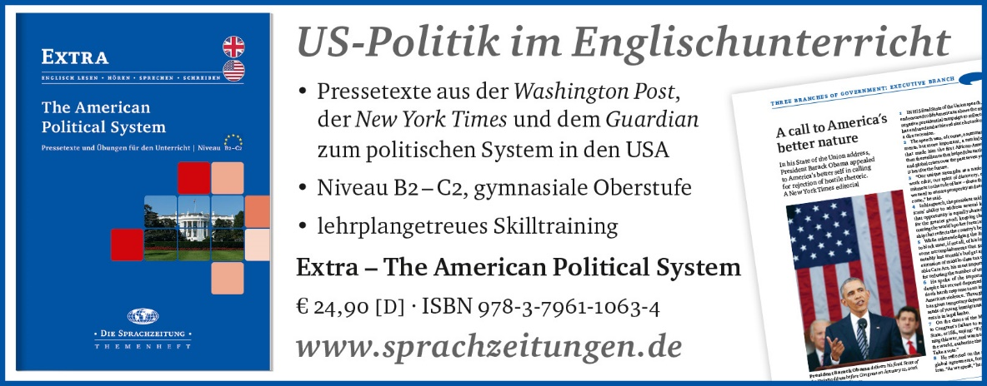

Hinweis: Die Zugangsdaten zu Ihrem persönlichen Abo dürfen Sie nicht an Dritte weitergeben.

